Bikeshare analysis project

[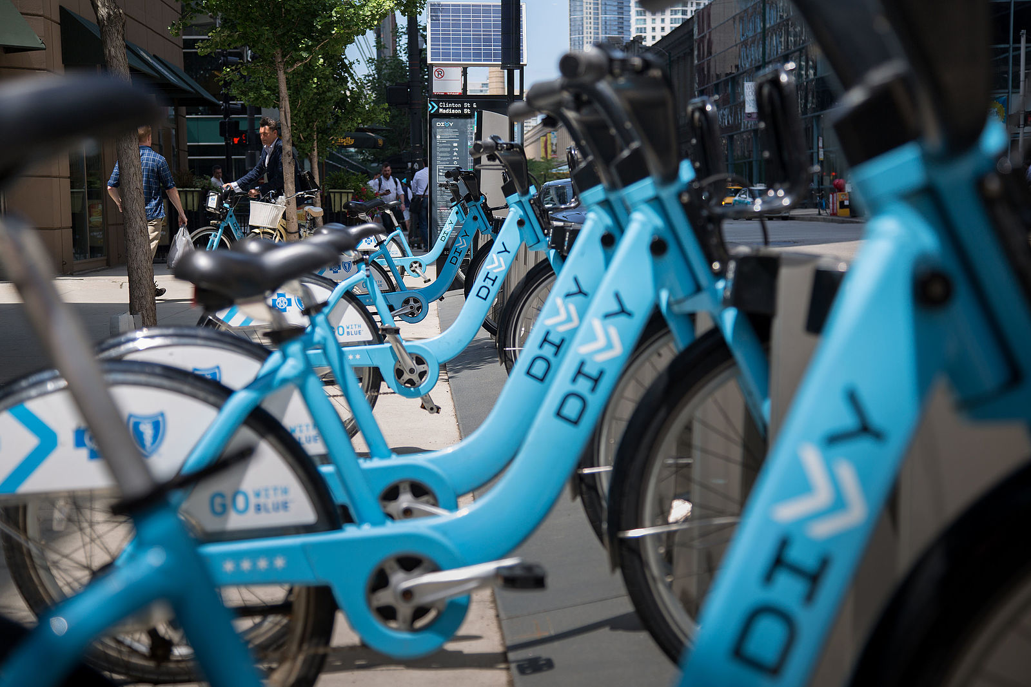](https://github.com/ahmed-gharib89/bike-share-udacity-dpnd/blob/master/images/divvy.jpg)

The 1st project in “professional Data analysis” NANO degree from **Udacity**

*“Learn how to use python in data analysis”*

# Overview

explore data related to bike share systems for three different cities in USA [Chicago, New York City, and Washington],

# Python language used to

1. Creating interactive commands with the user in the terminal to present the required statistics
2. After receiving the valid inputs from the user, the program will start to present some required descriptive statistics information

# Descriptive statistics information

## Calculating the Most Frequent Times of Travel

* the most common month
* the most common day
* the most common start hour

## Calculating the Most Popular Stations and Trip

* the most common start station
* the most common end station
* the most common start and end stations

## Calculating Trip Duration

* the total travel time in seconds and hours.
* the mean travel time in seconds and hours

## Calculating User Stats

* the counts of user type ( Subscribe & Customer )